Web Address to access the project with my current set up:

[**http://localhost/weeklycalendar/login.php**](http://localhost/weeklycalendar/login.php)

(Feel like I should say that the folder named Sex 2 on the sidebar of the pics is for my Human Sexuality 2 class, nothing raunchy)

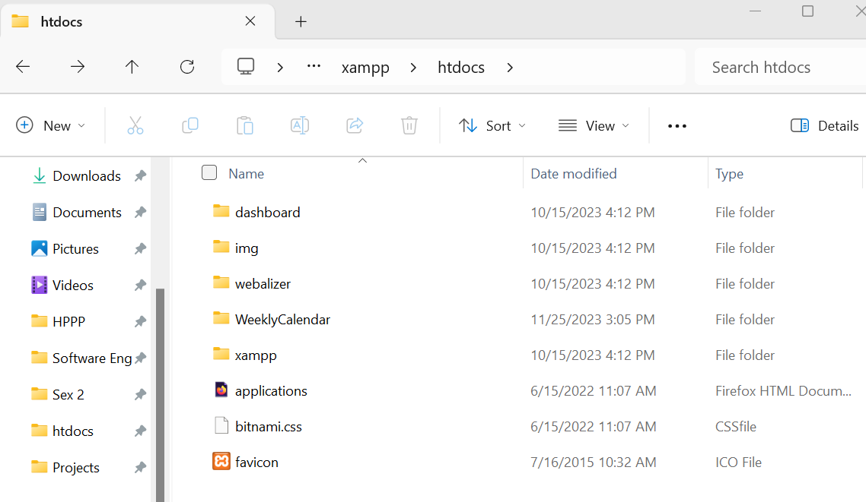

I have if set up so that the WeeklyCalendar folder is where the working files are for the project.

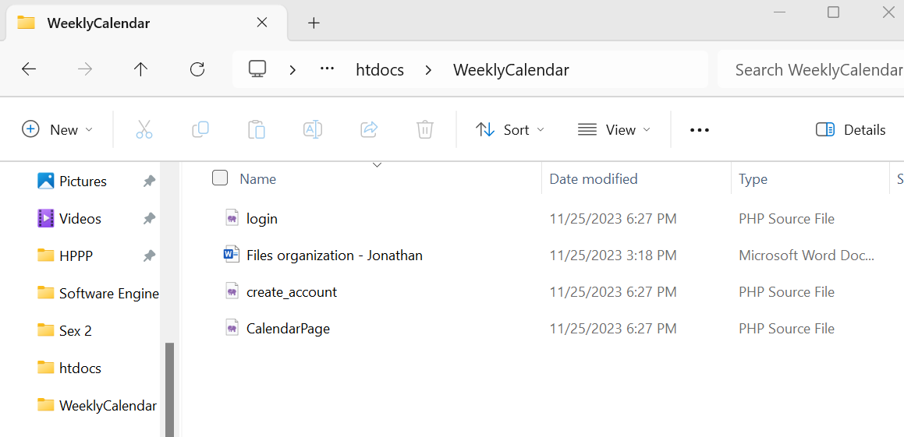

The naming convention for my files so far.